Contents

**How to Unlock Version PJT for April 2022 Period** 2

Step 1: Launch “**Forecast Input and Report**” Story. 2

Step 2: Right mouse click on table grid any cell🡪Click on **Manage Data Locks**. 3

Step 3: Choose the **Version and Time** that you wanted to unlock it. 3

Step 4: Choose the **Version** to display in the Table grid. 4

Step 5: Select **Apr (2022)** Period 🡪 dropdown to choose **Open** 🡪 Click on **Close** 4

**How to Lock the Version “PJT” for the April 2022 Period** 5

Step 1: Launch “**Forecast Input and Report**” Story. 5

Step 2: Right mouse click on table grid any cell🡪Click on **Manage Data Locks**. 5

Step 3: Choose the **Version and Time** that you wanted to lock it. 6

Step 4: Choose the **Version** to display in the Table grid. 8

**How to copy and paste data from Excel or Mass Data Entry** 9

Step 1: **Copy** data from Excel 9

Step 2: Go to the “**Forecast Input**”🡪 Place the cursor. 9

Step 3: Pasted data for those group accounts. 10

Step 4: Now copy and paste for **remaining** group accounts too. 10

Step 5: Click on **Publish Data** 10

**How to do 6 months Forecast for PJT version** 10

**Allocation for Forecast Versions** 13

Update Allocation Period for FCT: Run Allocation 13

Update Allocation Period for PJT2: Run Allocation 15

Update Allocation Period for PJT: Run Allocation 18

**Forecast Input and Report Story: ACT column data populate** 19

**PY Actual Data Population in Forecast Input and Report Story** 21

**Version Management** 23

# **How to Unlock Version PJT for April 2022 Period**

## Step 1: Launch “**Forecast Input and Report**” Story.

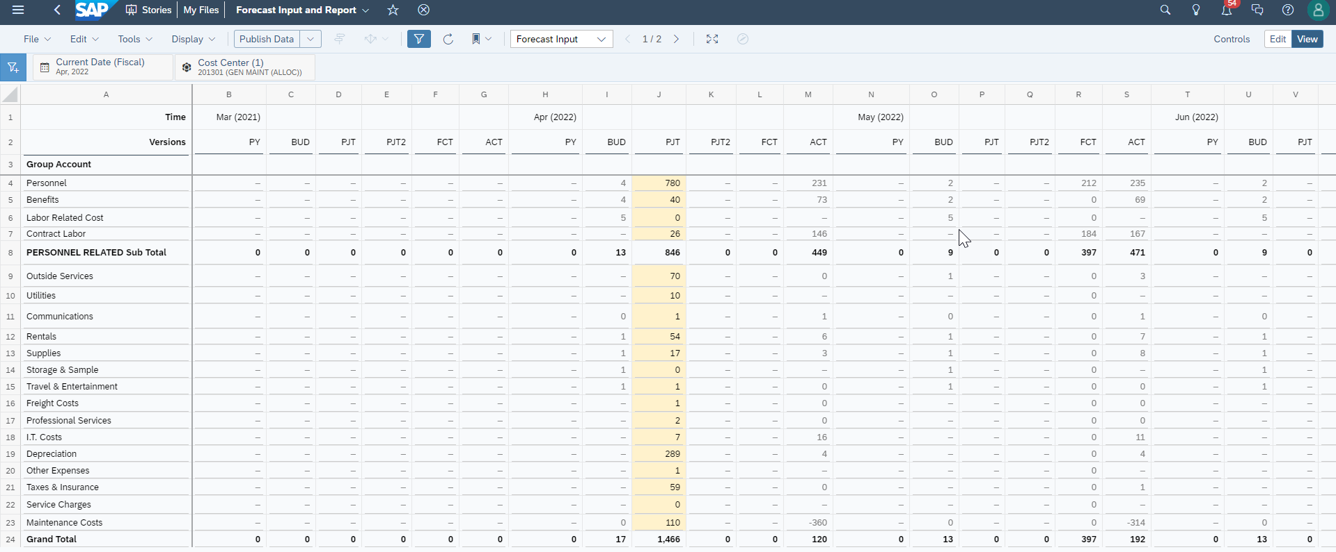

## Step 2: Right mouse click on table grid any cell🡪Click on **Manage Data Locks**.

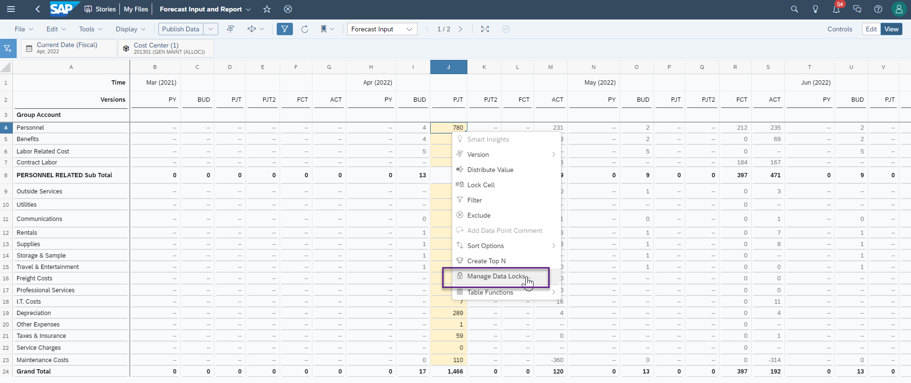

## Step 3: Choose the **Version and Time** that you wanted to unlock it.

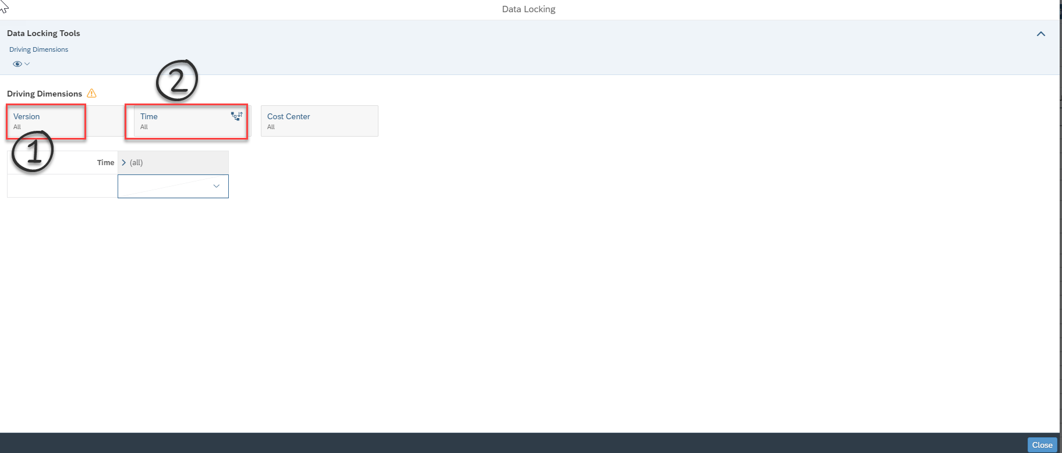

Click on Version 🡪 Search for Version “**PJT**” 🡪 Select🡪 click on **OK**

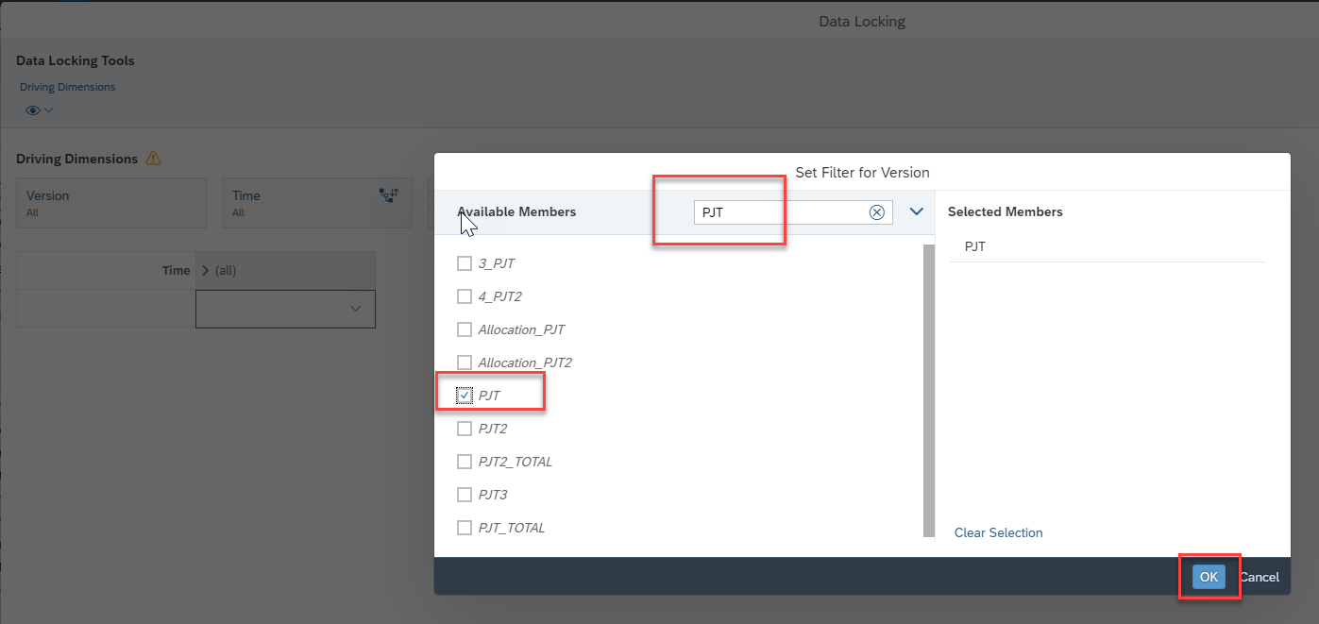

Same the same steps for TIME 🡪 Choose **2022**🡪Click on **OK**

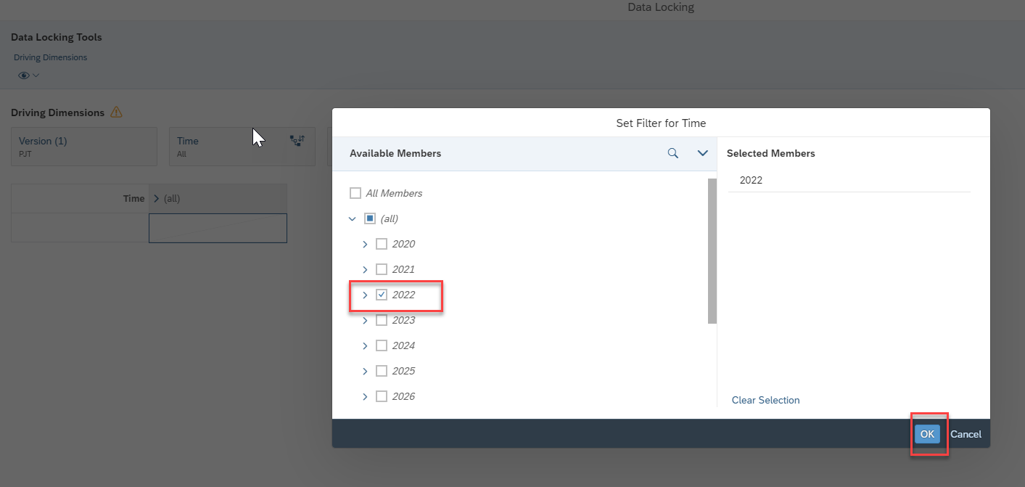

## Step 4: Choose the **Version** to display in the Table grid.

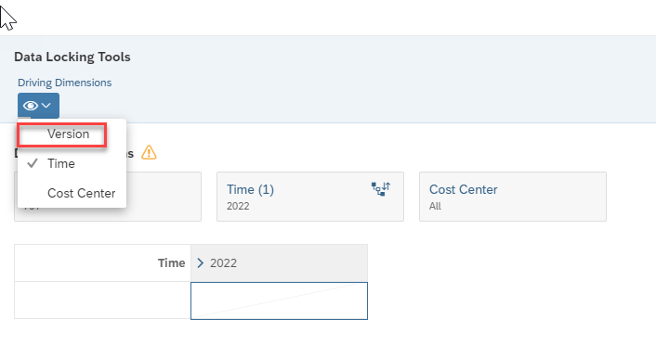

## Step 5: Select **Apr (2022)** Period 🡪 dropdown to choose **Open** 🡪 Click on **Close**

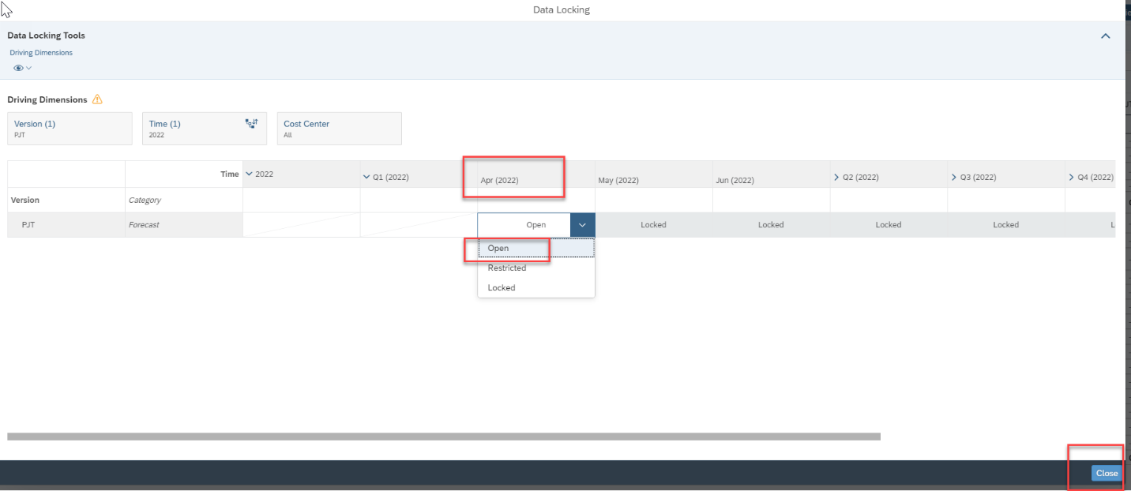

# **How to Lock the Version “PJT” for the April 2022 Period**

## Step 1: Launch “**Forecast Input and Report**” Story.



## Step 2: Right mouse click on table grid any cell🡪Click on **Manage Data Locks**.



## Step 3: Choose the **Version and Time** that you wanted to lock it.



Click on Version 🡪 Search for Version “**PJT**” 🡪 Select🡪 click on **OK**



Click on Time 🡪 Choose “**2022**” 🡪 Select🡪 click on **OK**



## Step 4: Choose the **Version** to display in the Table grid.



Step 5: Select **Apr (2022)** Period 🡪 dropdown to choose **Locked** 🡪 Click on **Close**

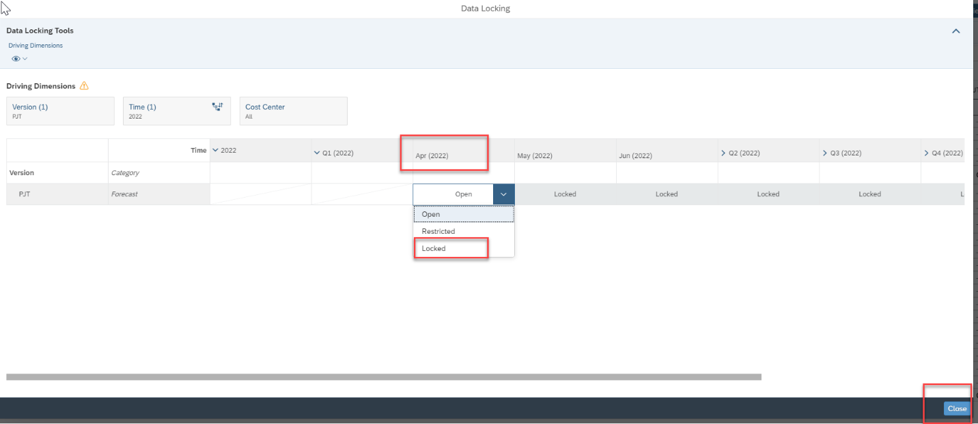

# **How to copy and paste data from Excel or Mass Data Entry**

Prepared sample data for this simulation purpose.

## Step 1: **Copy** data from Excel

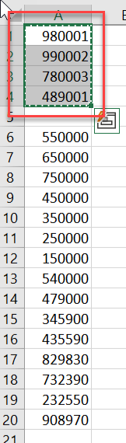

## Step 2: Go to the “**Forecast Input**”🡪 Place the cursor.

In this case I choose the data paste for the Personnel, Benefits, Labor Related Cost and Contract Labor group accounts.

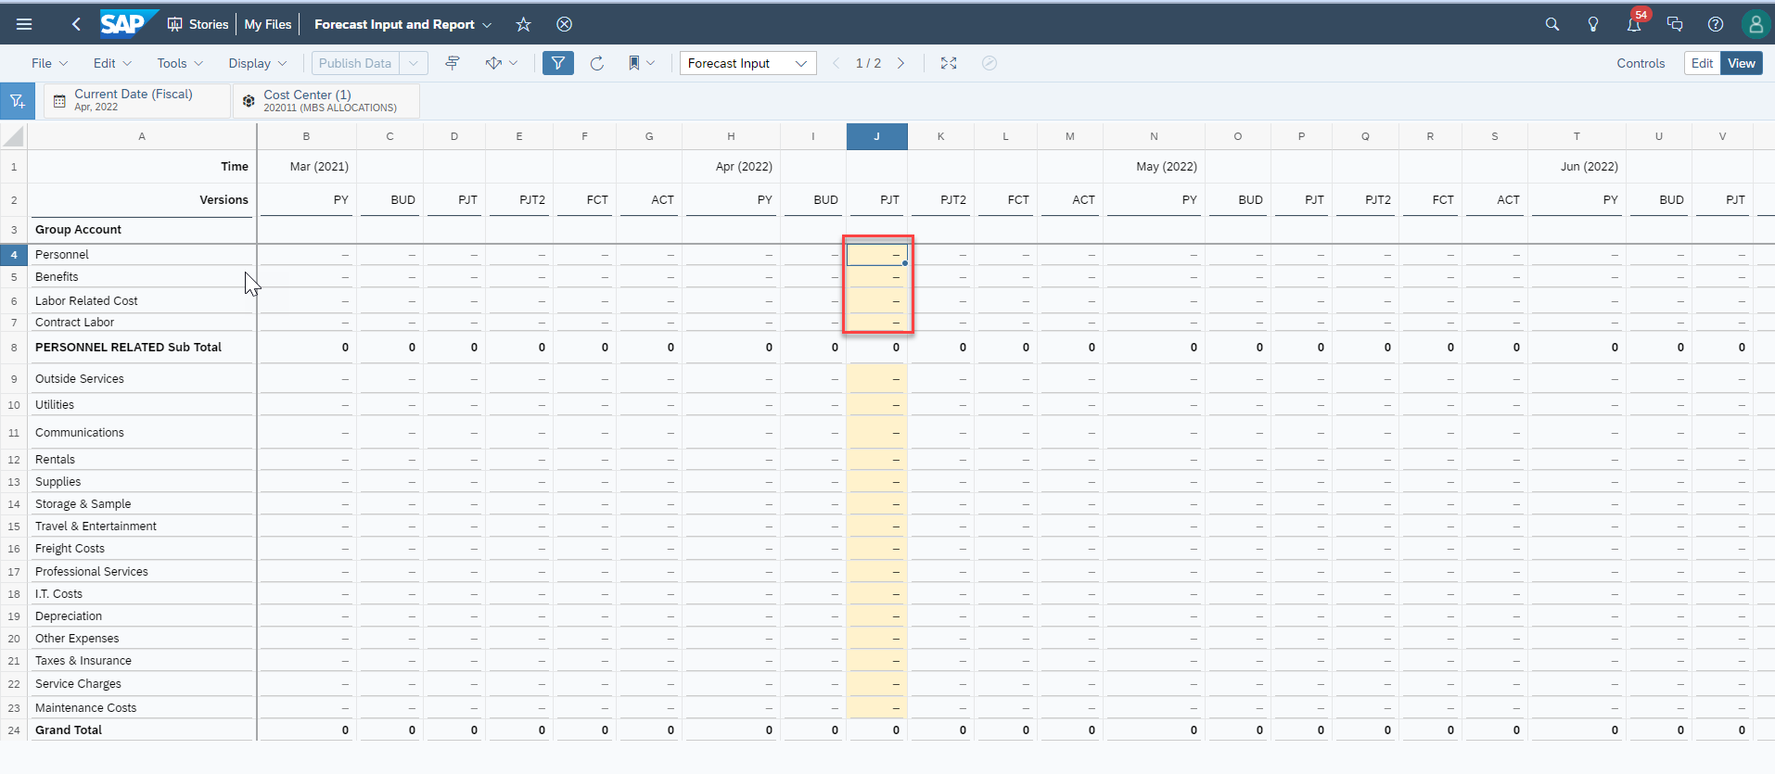

## Step 3: Pasted data for those group accounts.

## Step 4: Now copy and paste for **remaining** group accounts too.

## Step 5: Click on **Publish Data**

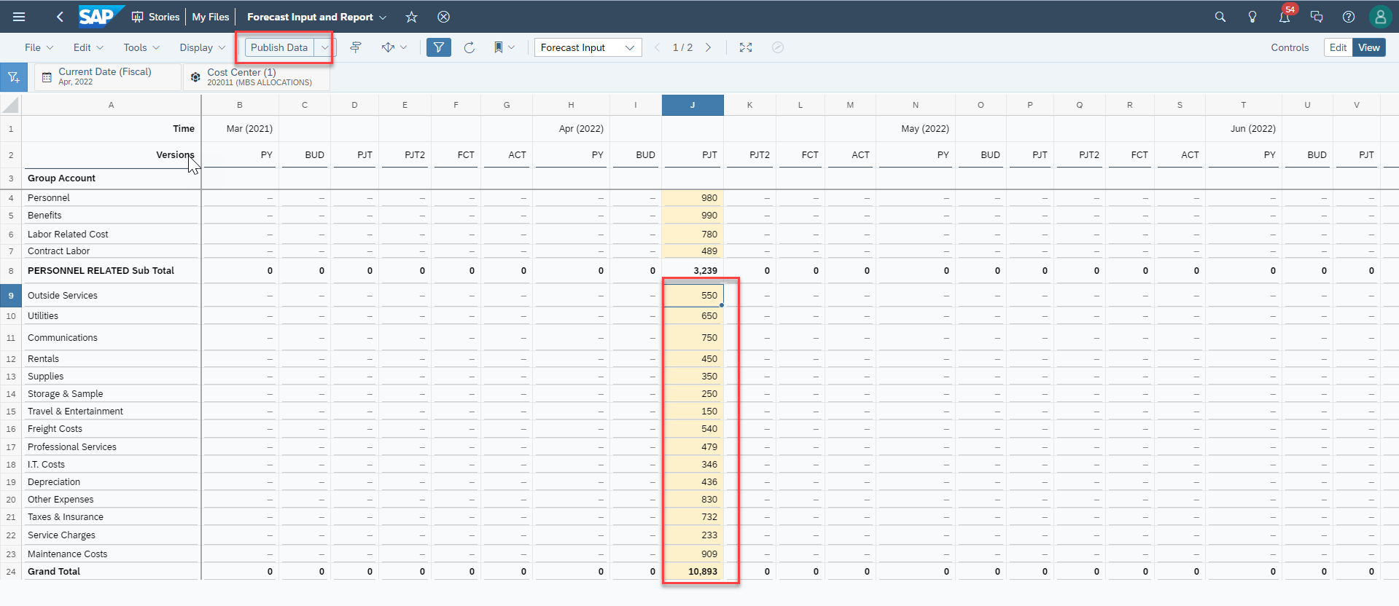

# **How to do 6 months Forecast for PJT version**

Step 1 : Click on Edit

Step 2 : Click on Designer.

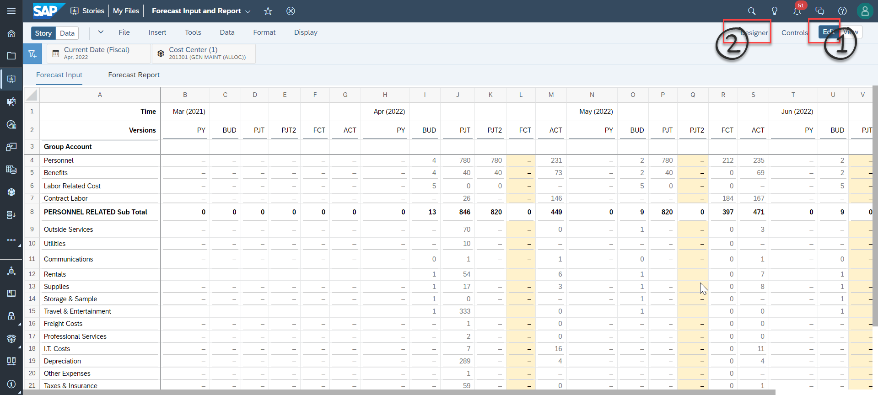

Step 3: Select Table and Version PJT.

Step 4: Select the Builder

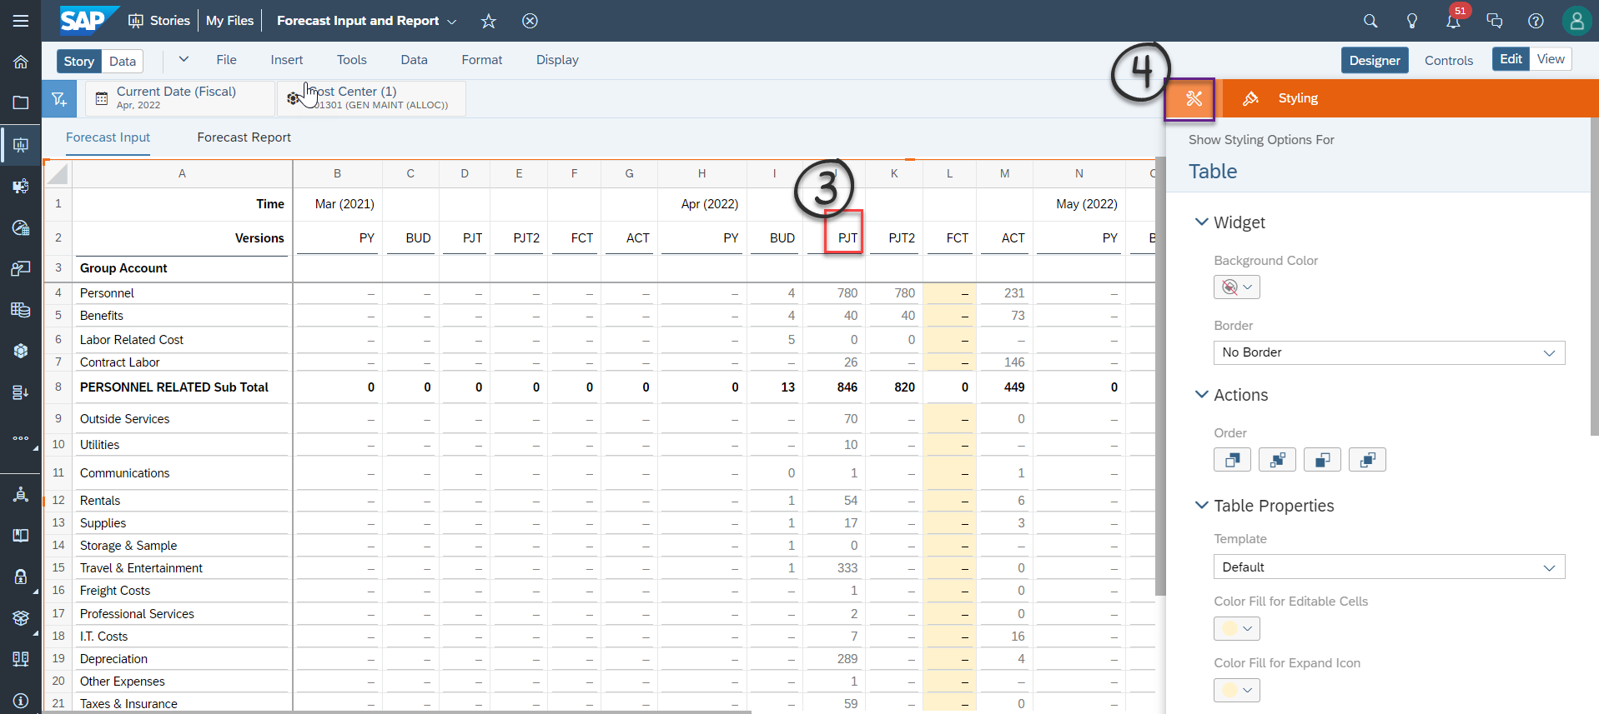

Step 5: Click on Time

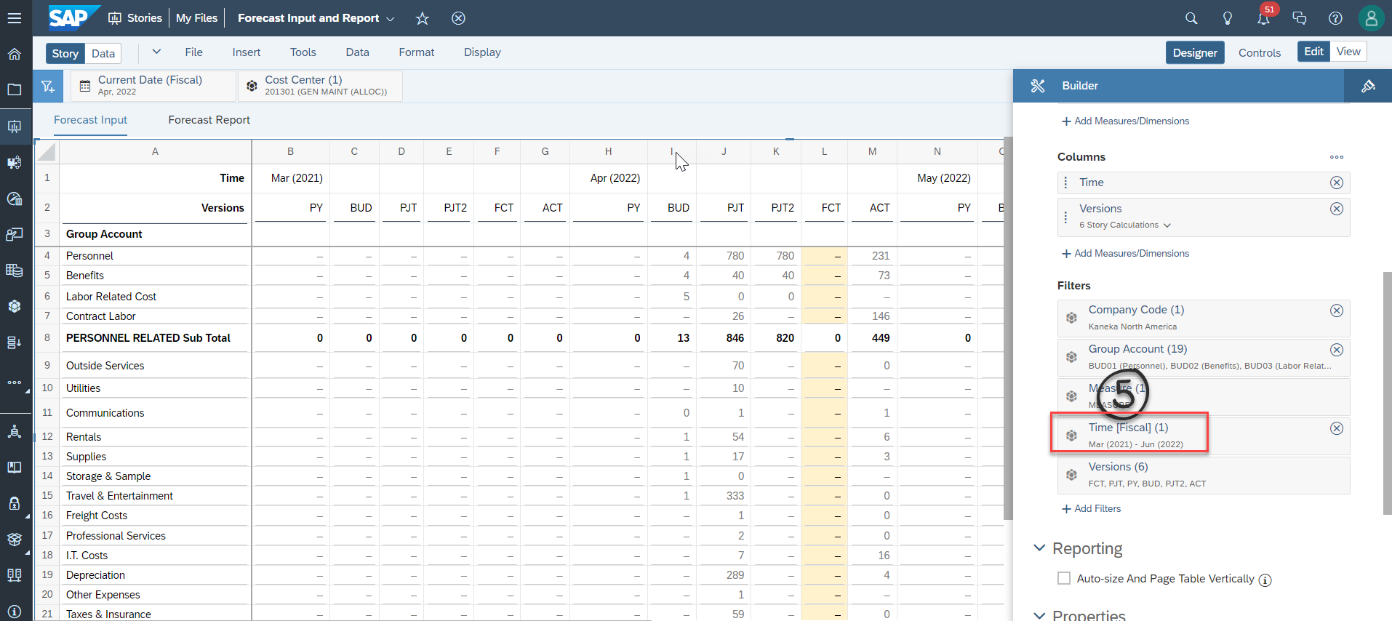

Step 6: Look ahead period currently set it as 2

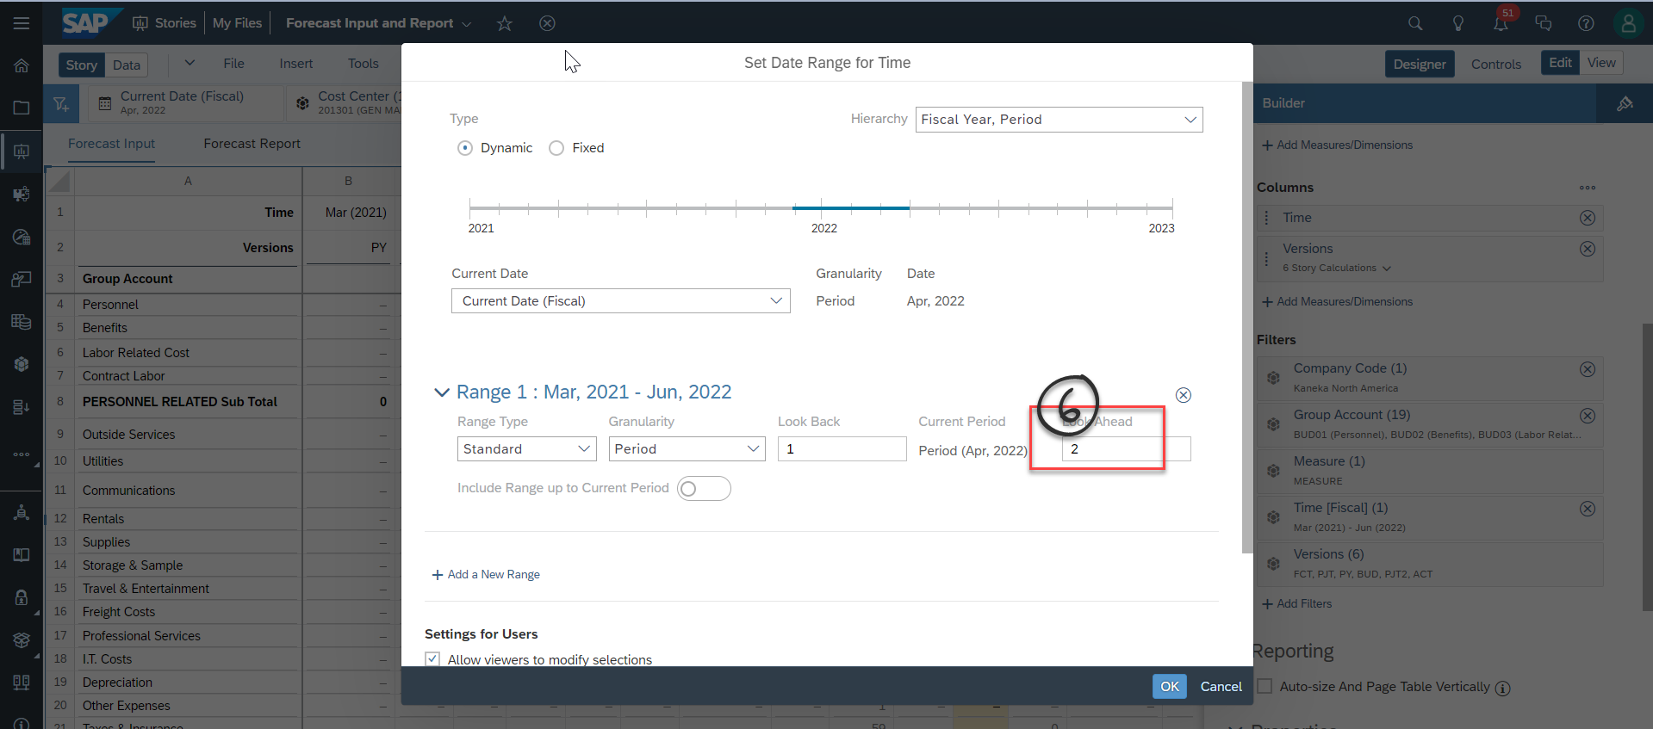

Step 7: Change look ahead period value from 2 to 5 and then click on OK.

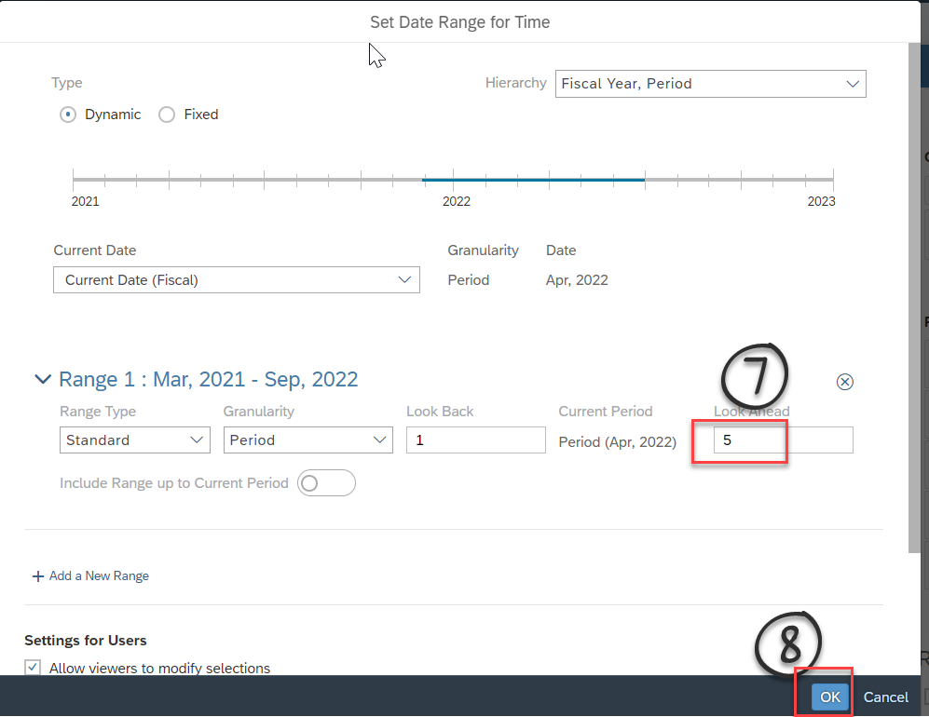

Step 9: Click on View 🡪 Now you can able to see all 6 periods in the input story and allow you to make planning.

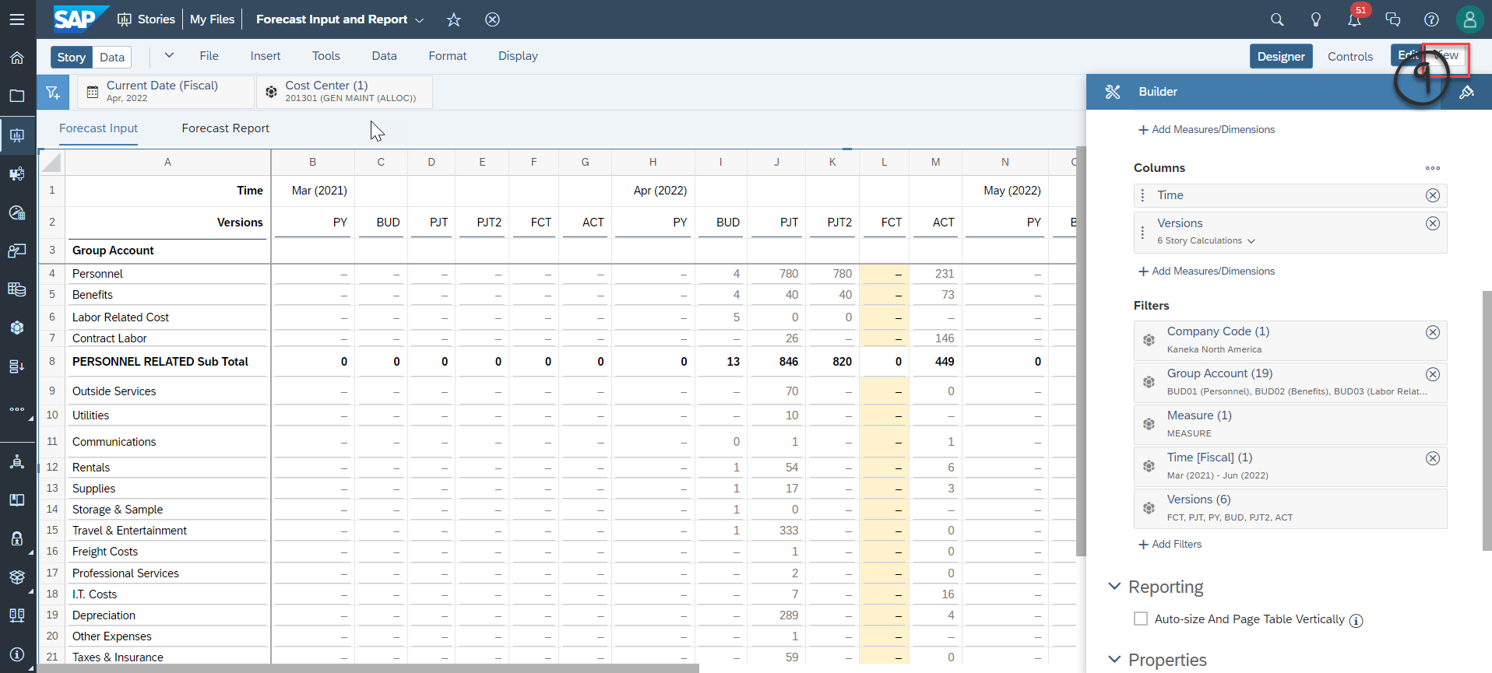

# **Allocation for Forecast Versions**

Before kick start new month forecast activities. Update the month that you wanted to run the allocation with respective versions.

## Update Allocation Period for FCT: Run Allocation

FCT Allocation will NOT work without updating correcting period. It always works for single allocation period only. In order to change period, please follow the below steps as below..

Step 1: Launch the “**CPD Forecast Allocations & Rates - Dev** “ Story

Step 2: Click on EDIT 🡪 Click FCT : Run Allocation 🡪 Edit multi action trigger

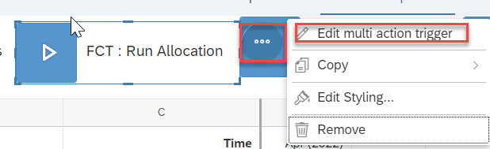

Step 3: Select the Open in Designer. Follow the below print screen.

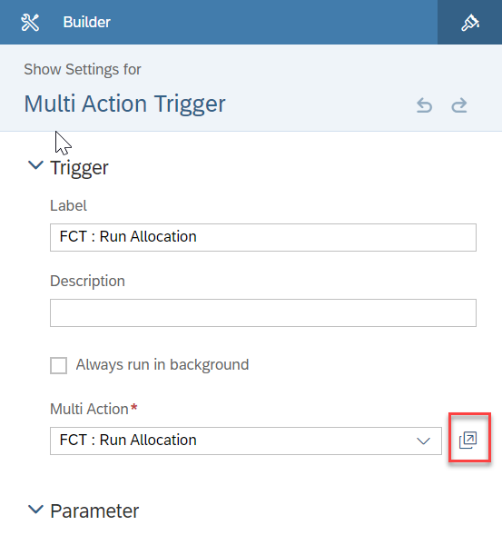

Step 4 : Select the FCT_TOTAL 🡪 Open Data Action as below print screen.

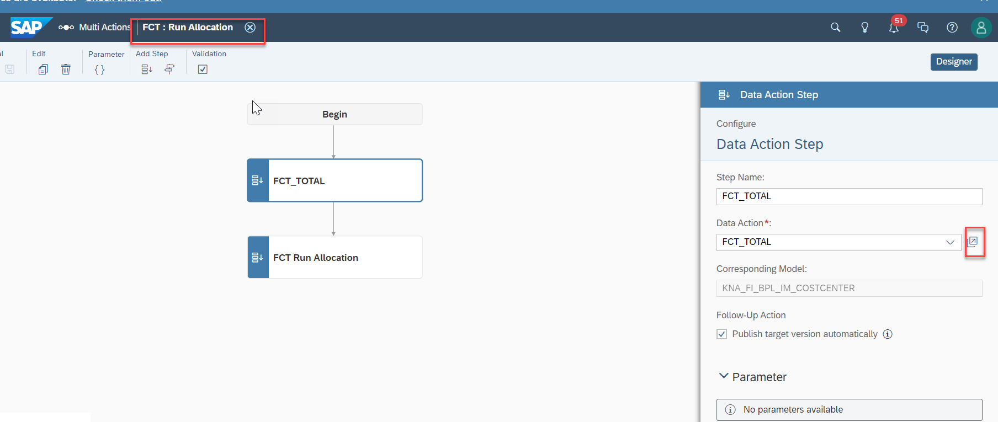

Step 5: Update the period that you wanted to run the allocation. Period format is YYYYPP and period should be within double quotation.

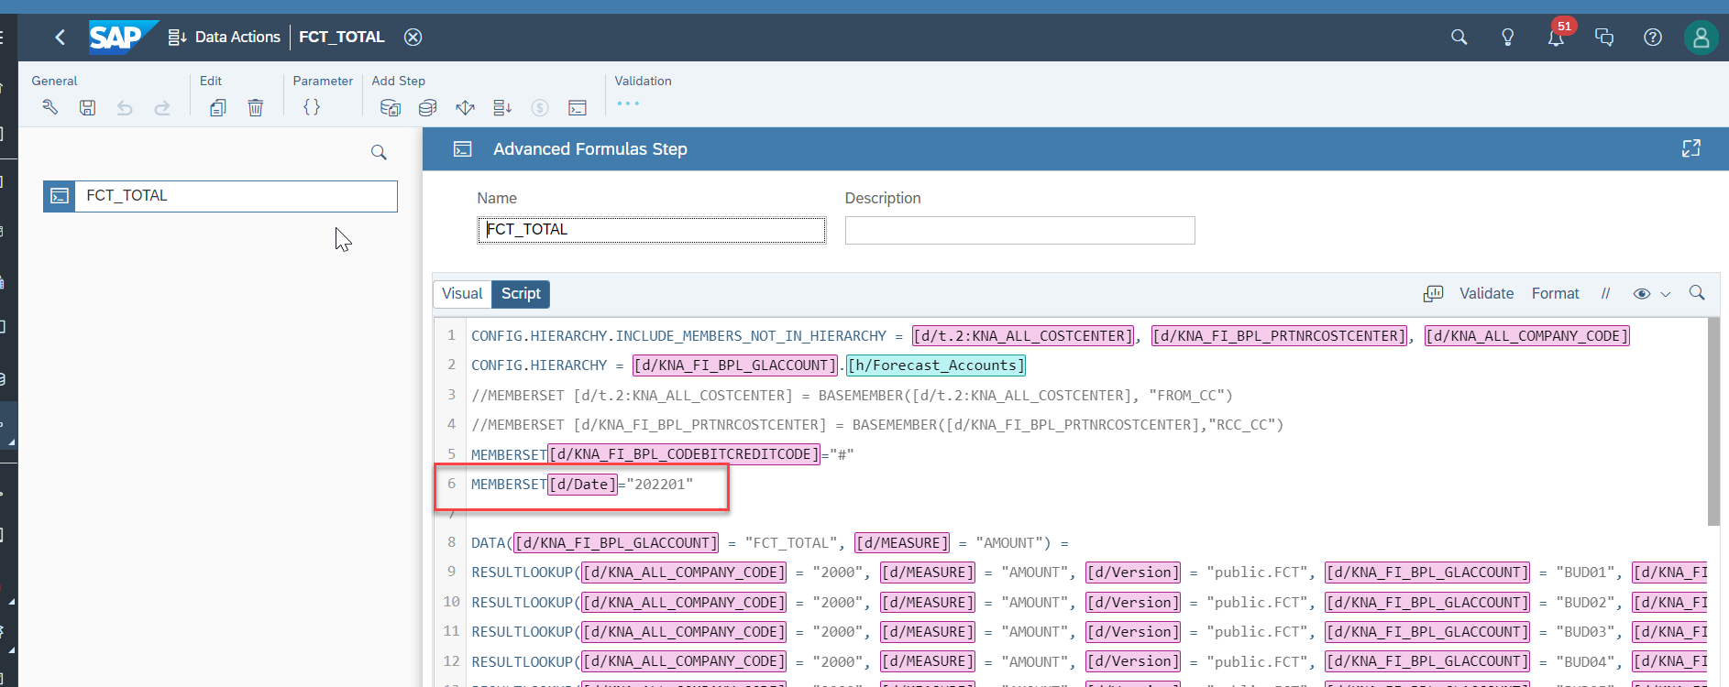

Step 6: Validate and Save it and click on back arrow to come to previous screen.

Step 7 : Select the “FCT Run Allocation” 🡪 Click on Open Data Action”

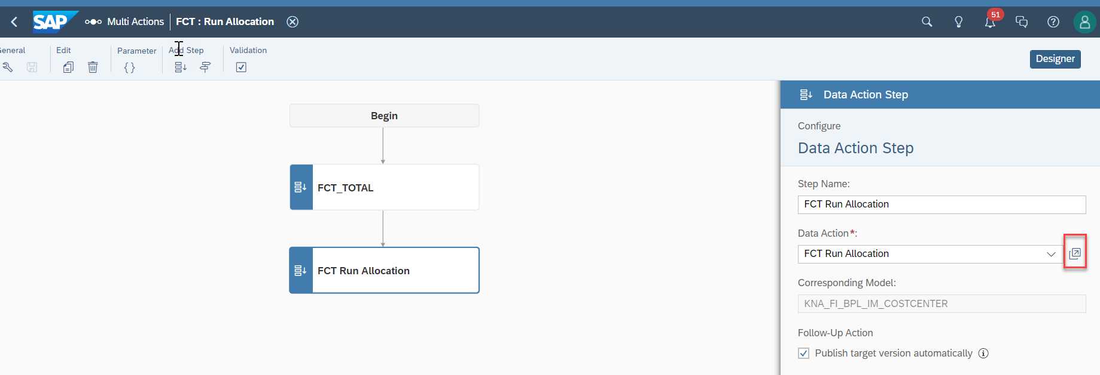

Step 8: Update the Period in Row 5. Update the period that you wanted to run the allocation. Period format is YYYYPP and period should be within double quotation.

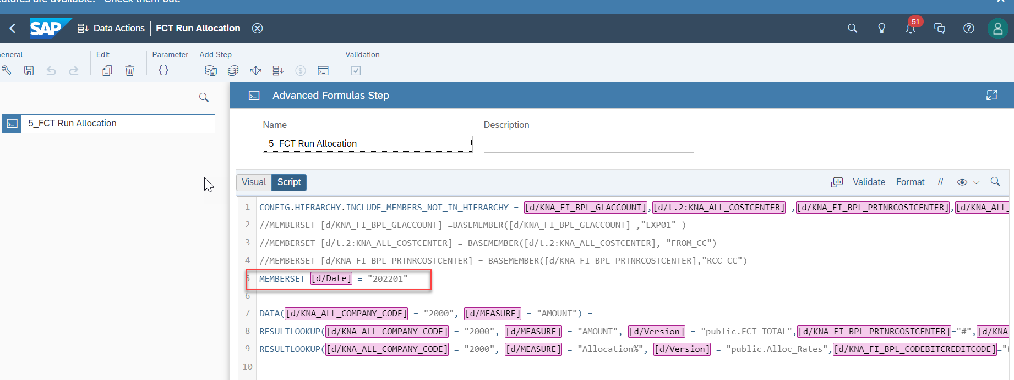

Step 9: Validate, save it and come back to previous Screen.

## Update Allocation Period for PJT2: Run Allocation

PJT2 Allocation will NOT work without updating correcting allocation period. It always works for single allocation period only. To change period, please follow the below steps as below.

Step 1: Launch the “**CPD Forecast Allocations & Rates - Dev** “Story

Step 2: Click on EDIT 🡪 Click PJT2: Run Allocation 🡪 Edit multi action trigger

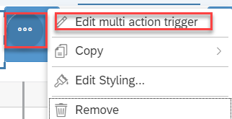

Step 3: Select the Open in Designer. Follow the below print screen

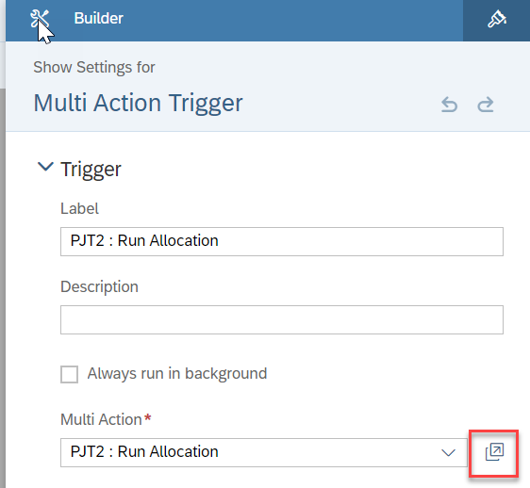

Step 4 : Select the PJT2_TOTAL 🡪 Open Data Action as below print screen.

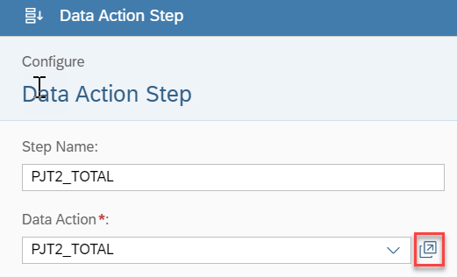

Step 5: Update the period that you wanted to run the allocation. Period format is YYYYPP and period should be within double quotation.

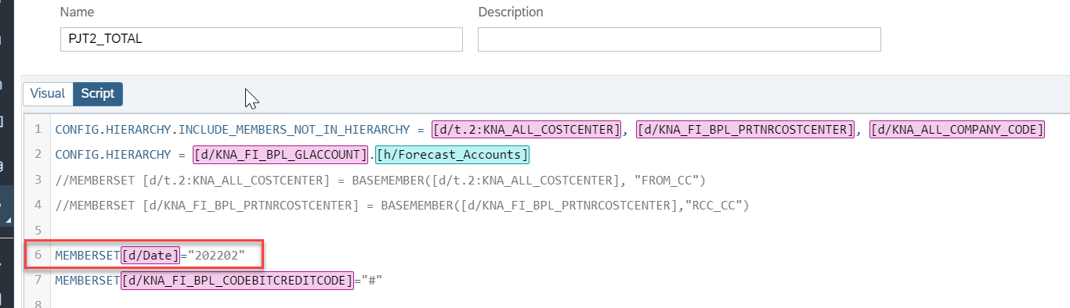

Step 6: Validate and Save it and click on back arrow to come to previous screen.

Step 7 : Select the “PJT2 Run Allocation” 🡪 Click on Open Data Action”

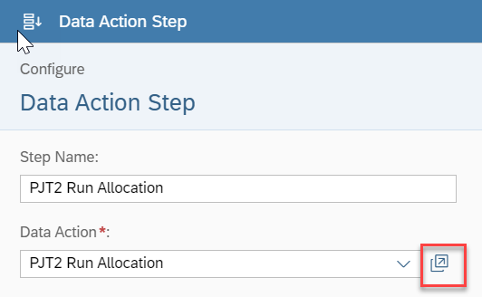

Step 8: Update the Period in Row 5, 8, 9 and 10. Update the period that you wanted to run the allocation. Period format is YYYYPP, and period should be within double quotation.

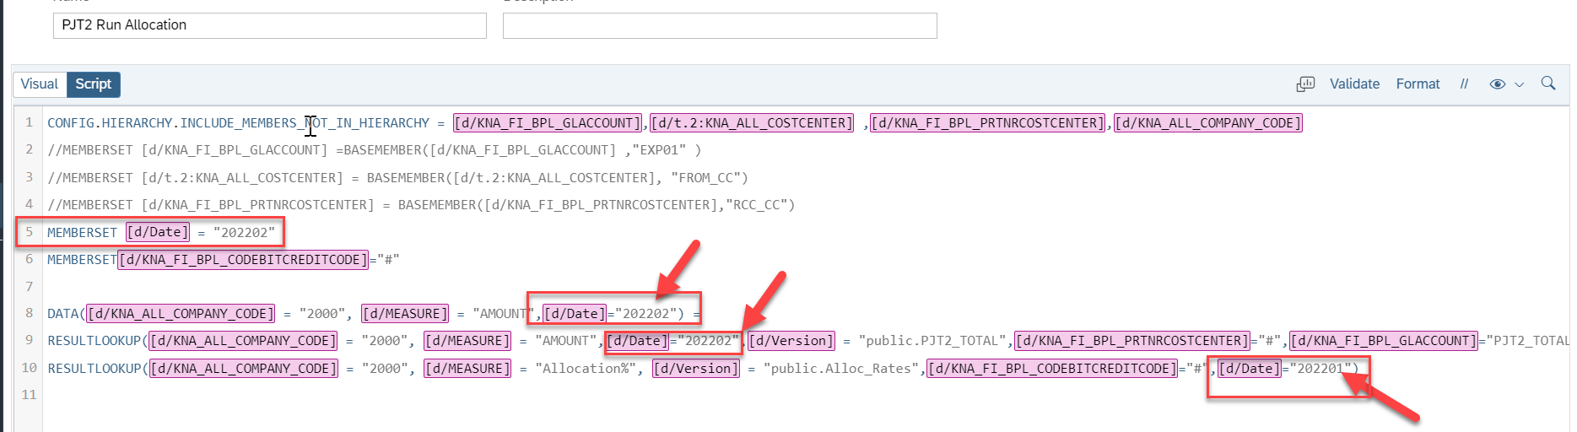

Step 9: Validate, save it and come back to previous Screen.

## Update Allocation Period for PJT: Run Allocation

PJT Allocation will NOT work without updating correcting allocation period. It always works for single allocation period only. To change period, please follow the below steps as below.

Step 1: Launch the “**CPD Forecast Allocations & Rates - Dev** “Story

Step 2: Click on EDIT 🡪 Click PJT: Run Allocation 🡪 Edit multi action trigger



Step 3: Select the Open in Designer. Follow the below print screen

Step 4 : Select the PJT_TOTAL 🡪 Open Data Action as below print screen.

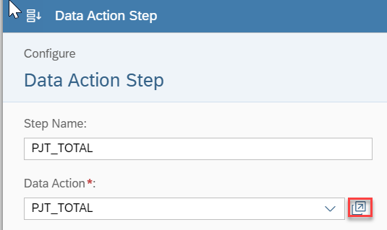

Step 5: Update the period that you wanted to run the allocation. Period format is YYYYPP, and period should be within double quotation. Update the period in Row 5 and 8.

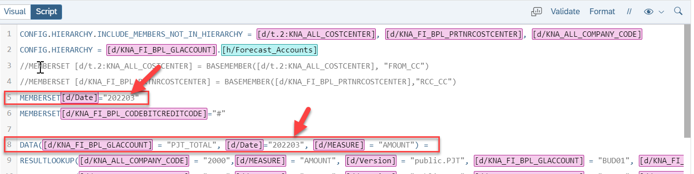

Step 6: Validate and Save it and click on back arrow to come to previous screen.

Step 7 : Select the “PJT Run Allocation” 🡪 Click on Open Data Action”

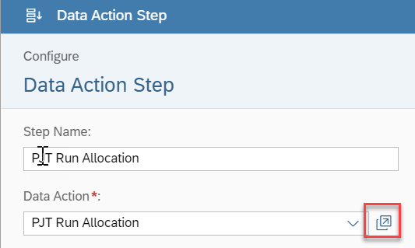

Step 8: Update the Period in Row 5, 8, 9 and 10. Update the period that you wanted to run the allocation. Period format is YYYYPP, and period should be within double quotation.

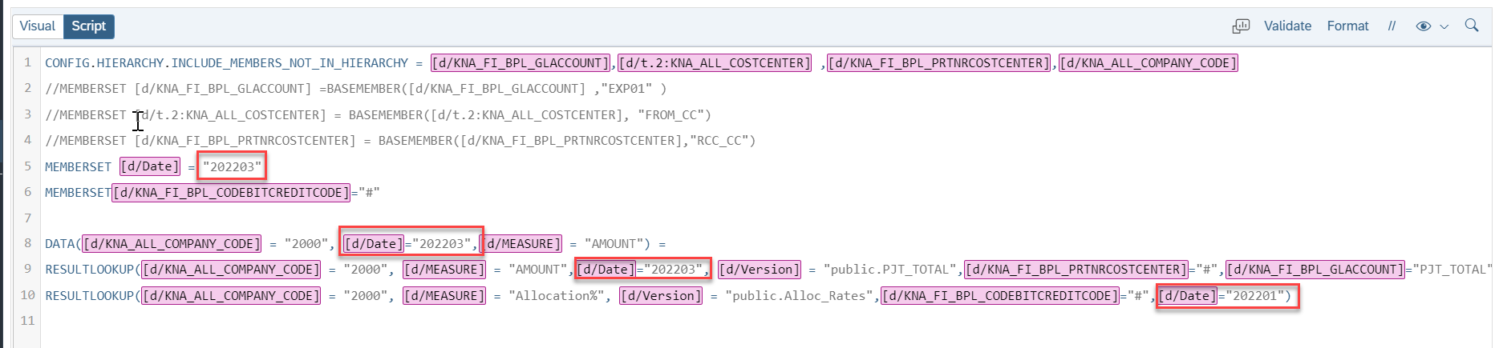

Step 9: Validate, save it and come back to previous Screen.

# **Forecast Input and Report Story: ACT column data populate**

**The Forecast Input page must** show Actual data at the Account group level instead of 6-digit GL accounts. SAC does not pull up actual data without displaying underlying GL accounts at the group account level. A data action “***Copy Yearly Actual***” to copy underlying GL accounts data into financial statement line/group account level with respectively from Actual version to 6_ACT Version.

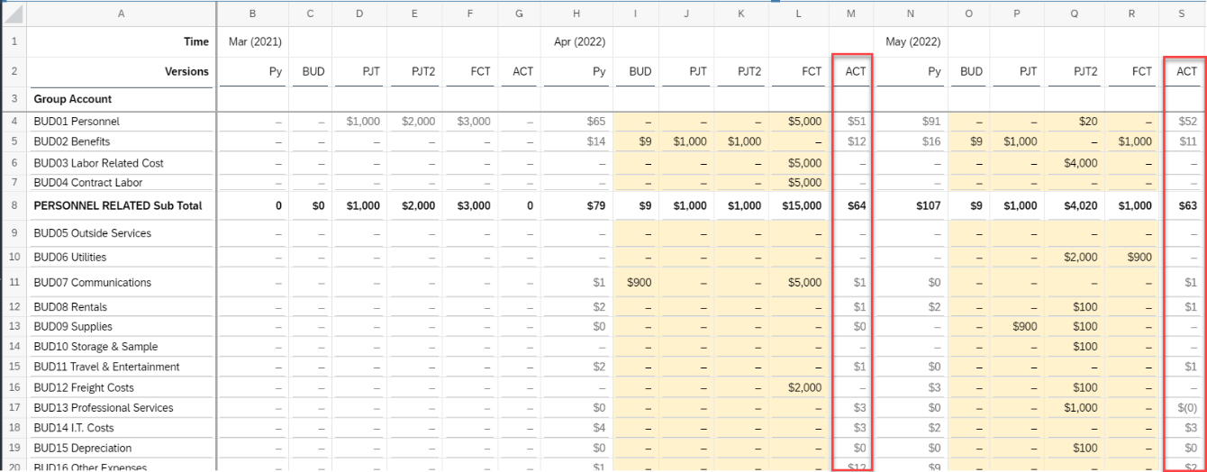

Step 1: SAC system admin resource 🡪 go to Data Actions

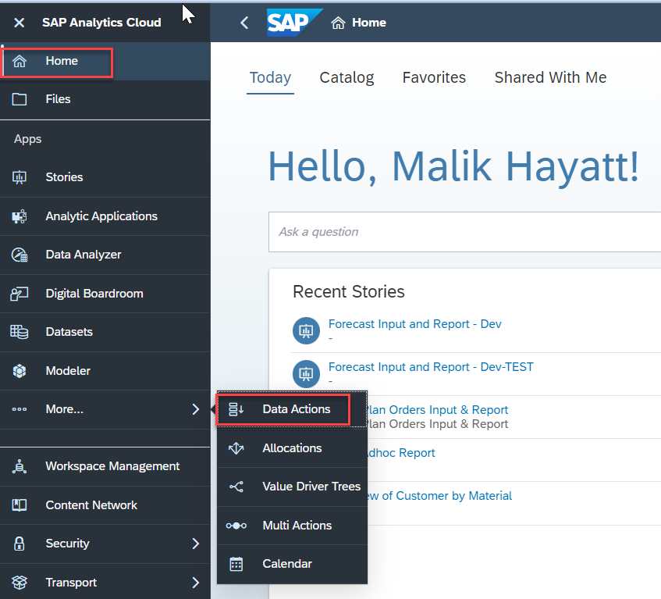

Step 2: Search for “Copy Yearly Actual” Data Action

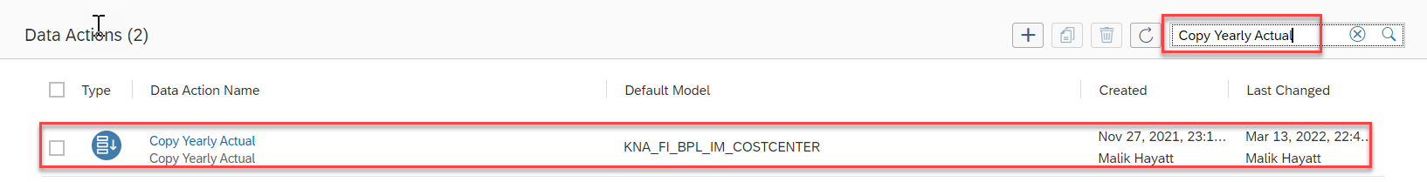

Step 3: Click on “Copy Yearly Actual” Data Action 🡪 Update the Year as below 🡪 Save.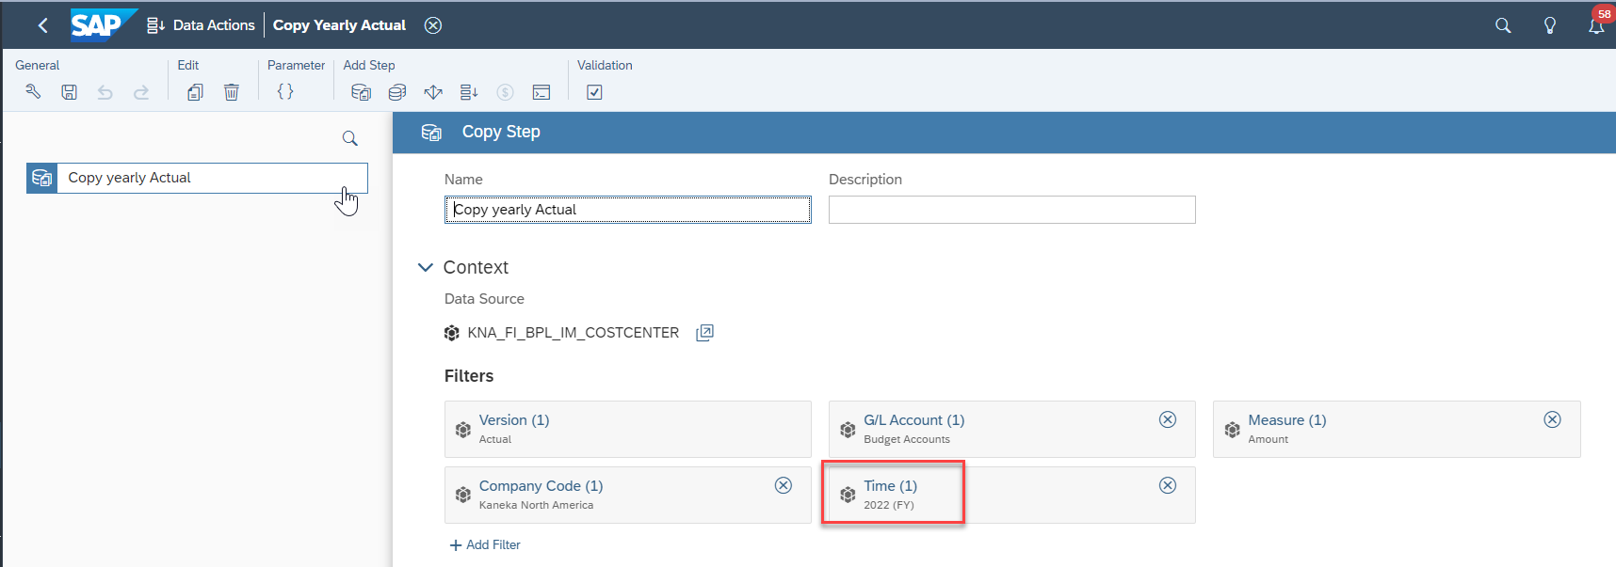

# **PY Actual Data Population in Forecast Input and Report Story**

PY actual data column is required to populate prior year actuals in the Report page. “Copy Actual into PY ACTUAL version” data action is required to run before initializing new planning year start.

Step 1: SAC system admin resource 🡪 go to Data Actions



Step 2: Search for “Copy Actual into PY ACTUAL version” Data Action

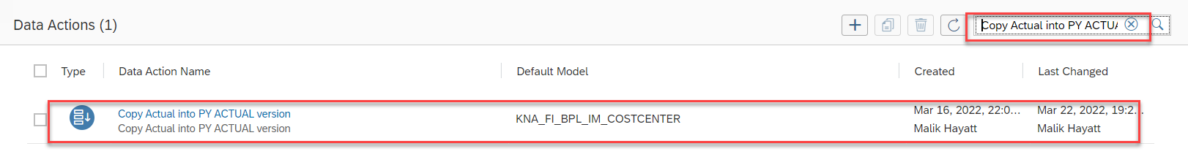

Step 3: Click on “Copy Actual into PY ACTUAL version” Data Action 🡪 Update the **From Year** and **To Year** as below 🡪 Save.

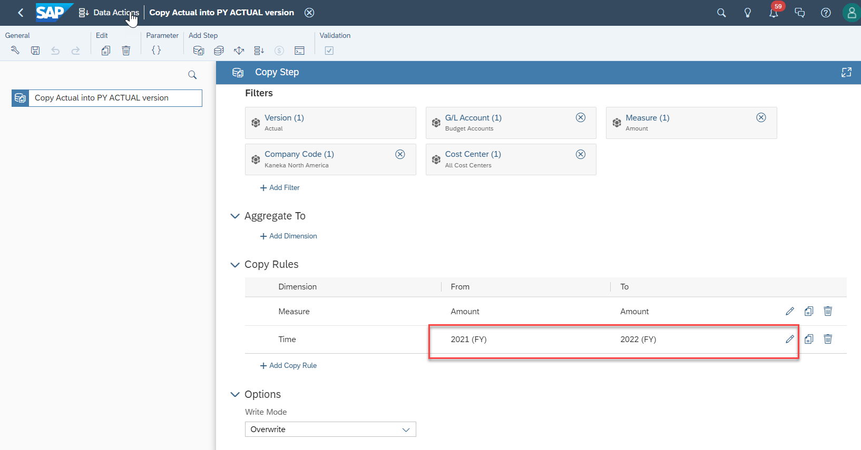

# **Version Management**

I am going to create one Planning version for this exercise. Version ID is “PY_ACTUAL_NEW”

Step 1: Open any existing story or adhoc story.

Step 2: Go to Tools 🡪 Version Management

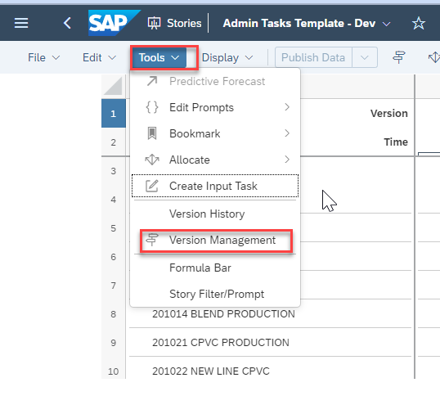

Step 3: You will get the list of public and private versions

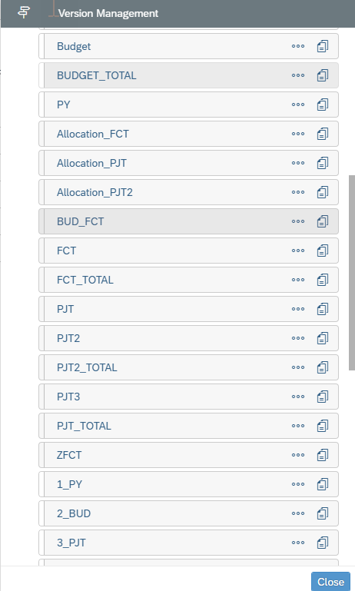

Step 4: Click on Copy from any one of the Version. In this case I have choose Budget version click on COPY.

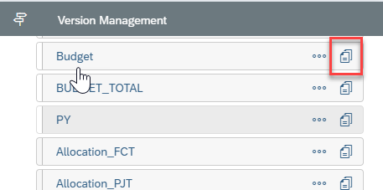

Step 5: Give name of version as “PY_ACTUAL_NEW 🡪 Change the Category from Budget to Planning 🡪 select the “Create a blank version” 🡪Unselect Include all comments 🡪 Click on OK.

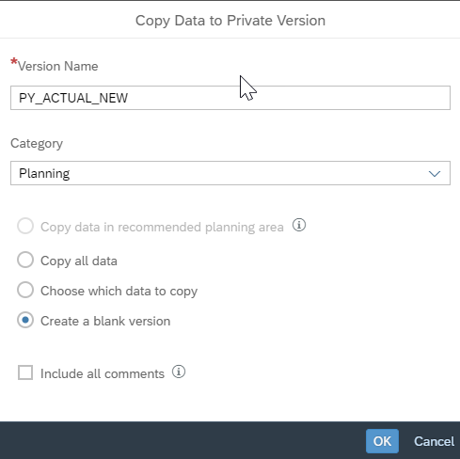

Step 6: PY_ACTUAL_NEW private version has been created.

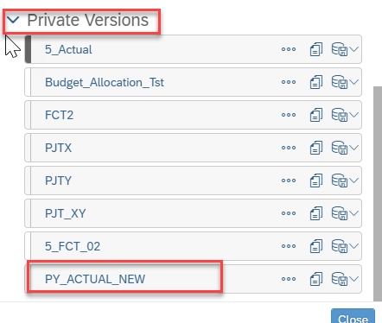

Step 7: Now select the private version PY_ACTUAL_NEW 🡪Click on “Publish As” as per below print screen.

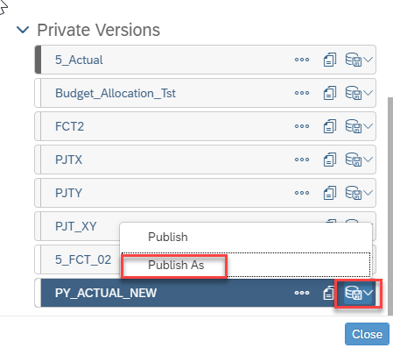

Step 8: Give Version Name as “PY_ACTUAL_NEW” 🡪Click on Publish.

